The Cabaret of the Bostikianes

#Bostikianes is a hybrid puppet show for adults. An intergenerational production where the female roles are represented by three different characters: a mother, a daughter and a grandmother. These symbolising the present, the future and the past, respectively. A life journey with a touch of humour and live music.

THE PUPPETS & THE MUSIC
ANNA MARIA BOSTIK

MUSICAL DIOGENISM
The grandmother is represented by Anna Maria Bostik, who suffers from "Musical Diogenism”. This is a condition that makes her physically unable to stop herself from singing passionately at any time she gets stimulated by a sound.
The technique of manipulating this puppet comes from the school of Neville Tranter (Stuffed Puppet Theatre), in which the performer creates the divide between the two characters, the grandmother and the caregiver. Thus, generating a surprising dialogue.
The legacy of women comes through from the living spirit of her favourite singers’ voices accompanied by pianist Danio Catanuto.

MARIA LLUM

The second puppet in the show represents our present, Maria Llum as a mother is a full-body human-sized puppet. This hybrid puppet is presented in two ways: first with the legs of the performer herself who dances and sings while pregnant, in the cabaret style of Espejo Negro; and secondly later reappearing manipulated by two puppeteers, inspired by the technique of the Belova-Iacobelli company, achieving an effect of fragmentation of the body.
She explains the difficulties of being a self-employed artist and a single mother who ends up giving birth on stage because her life is a frenzy! As mothers we wanted to share this experience from our present because we feel it’s necessary. We use humour as a channel to share this intimate world: childbirth and parenting. In this scene the makers are accompanied by the original songs that they have created.

CANDELA

The last puppet is a young woman, Candela, who represents the woman-of-the-future, that is living in her moment of innocence and discovery. For this, we needed a lot of mobility, as she is a provocative and young character. Singing and dancing become essential. The puppet is manipulated whilst being attached to the performer's body, particularly to the arms and legs, which move simultaneously to rap music. "Why will Women Save the Planet?", a book with a philosophy close to the heart of Candela’s character and to the makers, is quoted in the play and aims not only to provoke and generate reflection on the audience, but also to encourage collective action.

The Project Creators

ARTISTIC SHEET

This show, for adult audiences, is designed as a trilogy that can also be presented in fragments, meaning we can present it in parts, with each part lasting 40 minutes. We chose this format for ease of viewing and flexibility. The entire show lasts 1 hour and 10 minutes.

LAURA GUITERAS
Actress, announcer, singer and puppeteer; lover of languages and the world of puppets. His main instrument is the voice, sung and spoken. She has participated in theatrical productions such as A la Ville de Barcelona, Doña Rosita la soltera or Pels Pèls. Has a lsoco-starred in films such as La princesa del poligono or Violetes. She learned the art oftelling stories on the small screen, working at Cor de la Ciutat and in the musical field she stands out as co-founder of Taima Tesao (world pop) and Cargolé (contemporary flamenco). In 2015 consolidates her distinctive fact as a debutant puppeteer singer Mrs. Brownie, a tribute to black music. She is currently artist-in-residence at Nau Bostik from where he generates different artistic proposals under the umbrella of Produccions Maria Palomo.

ARIADNA MARTÍ
A graduate in Catalan Philology from the UAB, she studied various courses in performance, contemporary dance, and circus. A performing arts professional for over twenty years, she has worked in various artistic and technical fields. She is a founding member of the street and giant puppet group Sarruga, working in creative and production roles. She has been a member of Projecte Vaca, for 15 years, the Association of Stage Creators. Within this framework, she has worked on organizing the Novembre Vaca and Primavera Vaca festivals and has directed several performances and readings on the theme of gender. She has directed poetry and women's performances such as Yo Soy Gloria Fuertes and Versos Perplexos, and dance-theater performances such as Hermanas de Rio. TNC advisor and currently a circus aerials instructor with children from the Quina Gràcia! and Shakespeare & Friends schools.

The Team

LIGHTING DESIGNER: Joaquin Guirado
SCENIC DESIGNER: Joan Manrique Navarro
MUSIC: Laura Guiteras, Manolo López and Danio Catanuto
DIRECTOR OF PUPPETS: María Castillo
COMMUNICATION: Eva Romero
TECHNICAL SHEET EL CABARET DE LES BOSTIKIANES
STAGE SPACE: Adaptable indoor and outdoor, minimum 4 x 4 meters.
SETUP: 3 to 5 hours, depending on the technical preparation of the space. Teardown: 2 hours.
SOUND: The company provides vocal and computer microphones for the tracks.
We need: - PA equipment with monitors for the singer and musician
- A MIC-DPA 4099 + CLIP for double bass or similar
LIGHTING: Power: 12,000 watts / 60 amps / 16 dimming channels.
The company provides the filters.

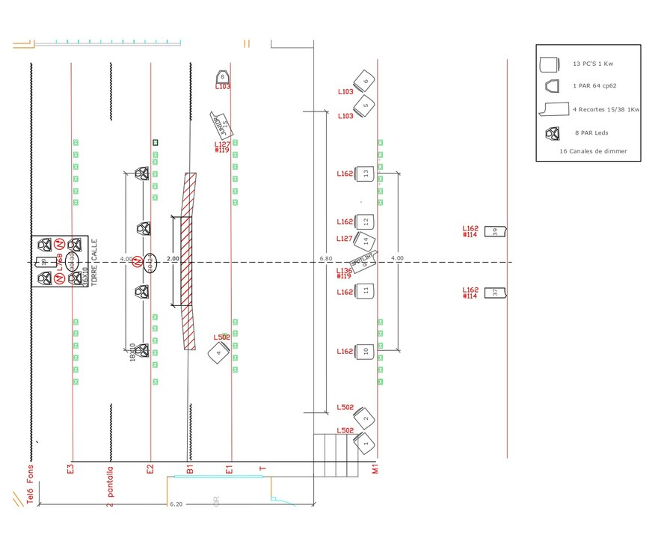
@: BOSTIKIANES@GMAIL.COM
TEL: +34 685 398 248 / +34 605 790 958
